Rest OAuth Basic Step

Objective

A RESTAPI defines a set of functions which developers can perform requests and receive responses via HTTP protocol such as GET and POST etc.

Make Rest API call by using authorization type as Basic OAuth.

UI

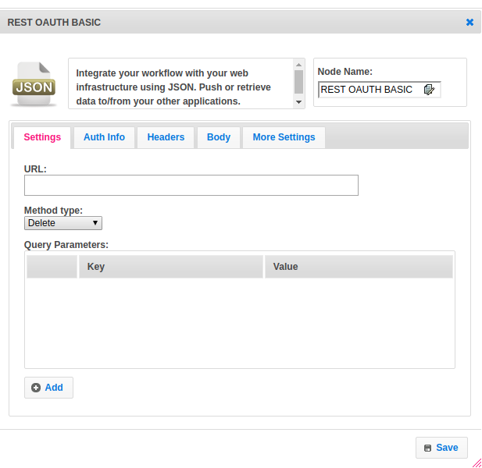

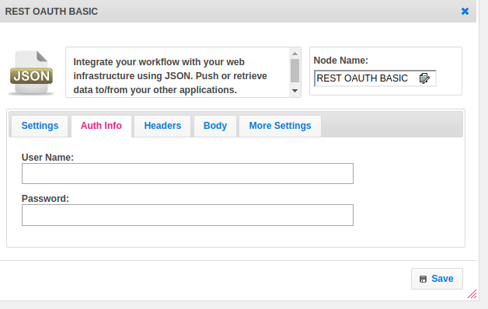

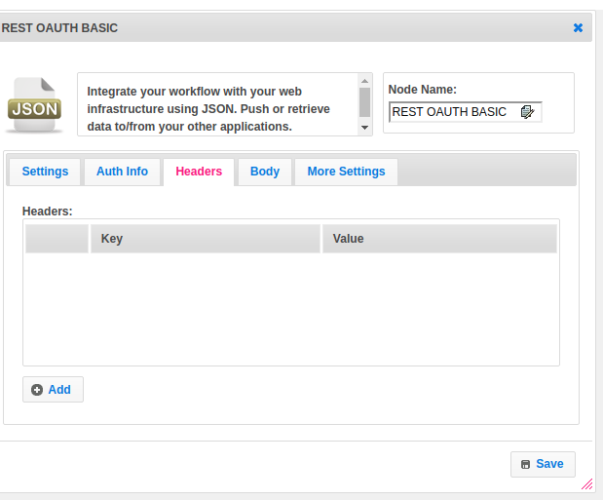

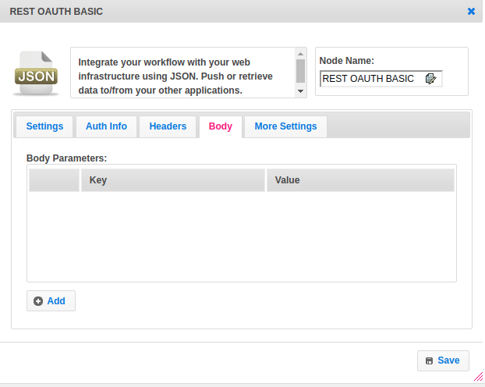

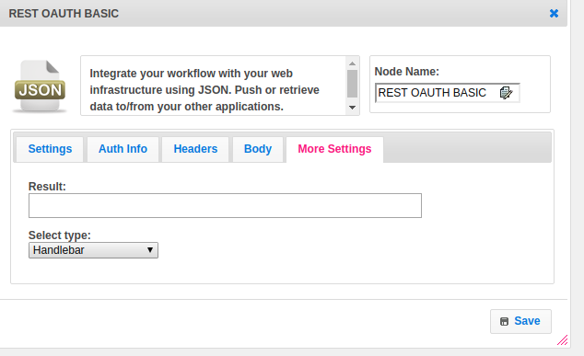

## Attributes

|  |  |
| --- | --- |
| **Attributes** | **Description** |
| **1. URL** | The URL is an essential part of a REST API. |
| **2. Method Type** | Following four HTTP methods are commonly used in REST-based architecture.  GET − Provides read-only access to a resource.  POST − Used to create a new resource.  DELETE − Used to remove a resource.  PUT − Used to update an existing resource or create a new resource. |
| **3. Query Parameters** | The query parameter or query string is the part of a [uniform resource locator](https://en.wikipedia.org/wiki/Uniform_resource_locator) (URL) which assigns values to specified parameters. The query string commonly includes fields added to a base URL.  Provide the parameters in the form of a key-value pair. |
| **4. User Name** | Give the username |
| **5. Password** | Give the password |
| **6. Headers** | Parameters included in the request header, usually related to authorization.  Provide the parameters in the form of a key-value pair. |
| **7. Body Parameters** | Parameters included in the request body.  Provide the parameters in the form of a key-value pair. |
| **8. Result** | Used to store the response of the request. |
| **9. Select Template** | Select Template is used to set the value type.  Value types are two types.  1.hb-HandleBarss  2.ftl-Freemarker Template Language. |

## Executor Description

Build a URL. For GET, HEAD and OPTIONS requests, parameters will be added to the query string in the requested URL.Check if it is basic authentication if basic then add required headers. By passing username and password to the basic method of Credentials class provided by OkHttp. Add to the header by passing the responsibility to create method as value and authorization as key.Add Headers given in the step. Set the method. Get Response. Check and assign the response content type.Add response in the string when the content type is JSON / plain text else read bytes and assign.

## Resource

Please refer the below link to get more details.

<https://dzone.com/articles/busy-developers-guide-restful>